UNBEKNOWNST
A SHORT FILM BY ANTONIO MICHAEL LEAKS
PRESS KIT

Running Time : 11 minutes
Language: English
Picture: Color
Aspect Ratio: 16:9
www.thinkoutsidethelines.net/unbeknownst

SYNOPSIS

What really happened on Saturday the 14th and who’s to blame? Unbeknownst is a story about the truth, explored from each character’s perspective. Kayla makes last minute changes to her plans for the day. Naomi focuses on her bright future while not allowing her past to affect the present state of things. Myles seeks to build on a great first date. But little do these three individuals know, their paths will collide and have unexpected consequences. Sometimes, there are three sides to a story.

DIRECTOR’S STATEMENT

The last few years have been a very interesting time to be alive in the world. With the rise of smart phones and the increase of social media outlets, the opportunity for people to communicate to each other has never been easier. However, in our efforts to stay connected and become better communicators, we have ironically become worse.
In UNBEKNOWNST, I sought to design a story to highlight the tragedy of the lack of communication between groups of people. And since this film examines the breakdown of dialogue between parties, I figured the most effective way to display this was to have the film itself be silent. My clear intentions were to craft a narrative that could only be fully understood if told from three different perspectives. If the series of events were told exclusively from one point of view, there would be a number of inaccurate assumptions that one could make about these characters. I looked at this film as an opportunity to explore a story from the bigger picture, seemingly singular instances which contributed to the chain of events as a whole.
This film first spawned as an idea for a music video. During the process, I quickly realized that although the accompanying song was fitting, a music video was not the right medium for this story. As I expanded on characters and plotlines, I brought in Erick Garrett who was instrumental in bringing these characters to life in his storyboards, as well as filling in any holes within the story. The vivid storyboards, drawn by the comic book artist, paid off in such a way that there was no real need for a traditional script. Adrian Ehlman provided the overall look and feel of the film’s visuals. His fearless attitude and ability to adapt in the moment made the process smoother than I initially imagined.
It was a great experience working with such a talented group of actors who were able to portray their characters the way I envisioned.
Aime Sosa fully grasped the nuances of “Kayla.” The naturalistic facial expressions she conveyed spoke louder than words.
Brandi King was thoroughly dedicated to give a great performance. I truly believed that she was “Naomi” whenever her scenes began.
Christopher Baker brought his keen ability to improvise to his portrayal of “Myles.” He brought to the screen some of the film’s best unscripted moments.
The level of energy Ike Torres brought to his role was invaluable. The cast and crew that worked with him were inspired to bring the same amount of intensity to the set.
This film was created to generate thoughts and discussions as to how we as individuals interact with either each other. This film, being my directorial debut, required a great deal of hard work and perseverance to see this project from its music video roots, to its fully realized film version, and I loved every minute of it. I hope you enjoy “Unbeknownst” as it was a pleasure making it for you.
- Antonio Michael Leaks

BEHIND THE SCENES

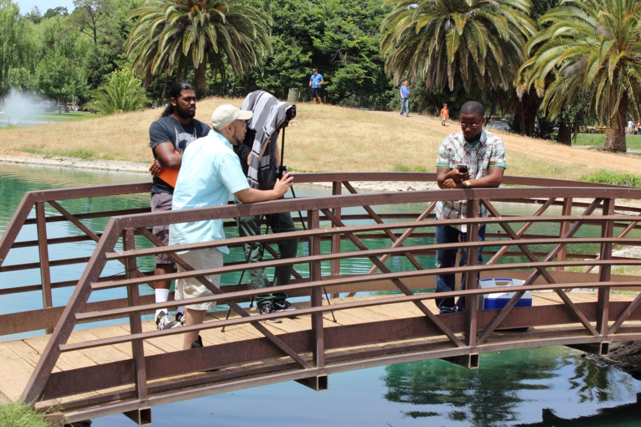
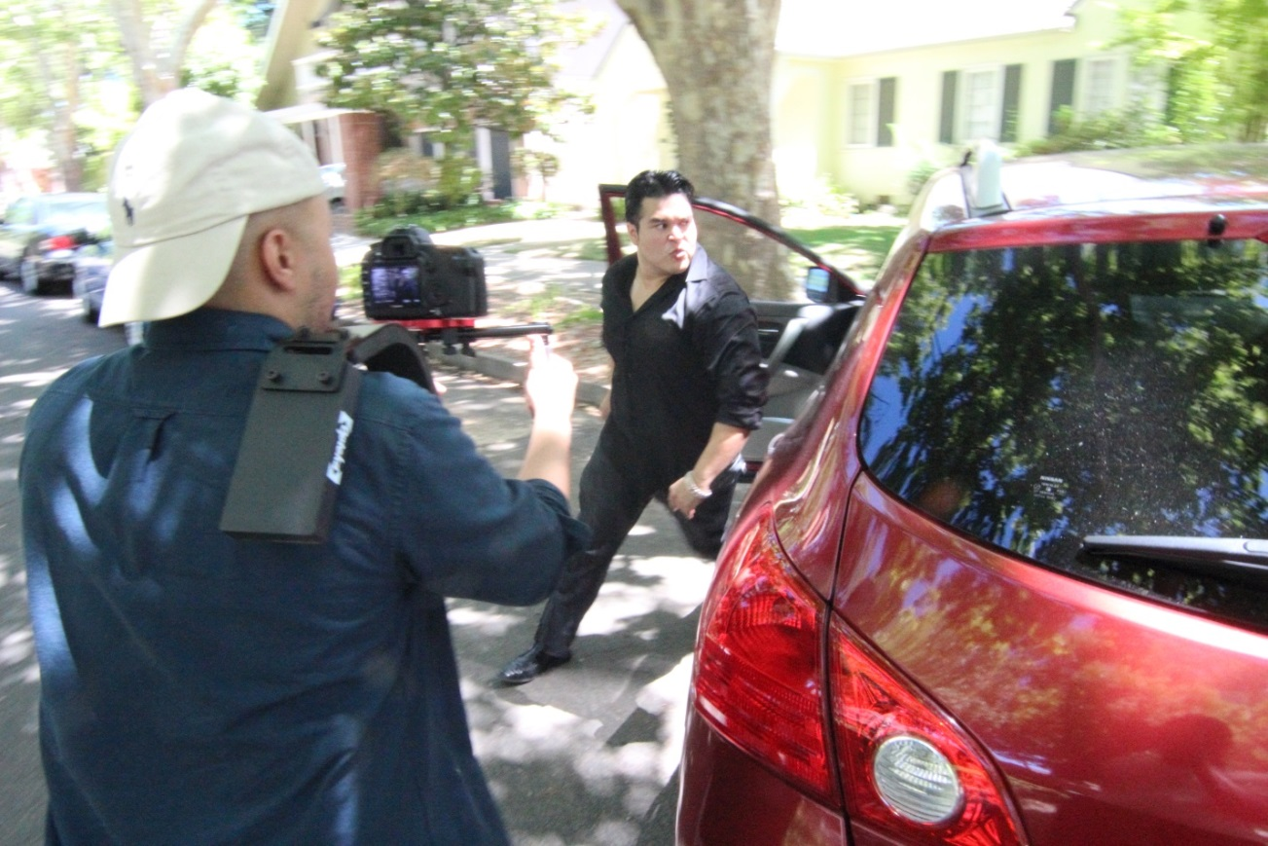
PRODUCTION STILLS

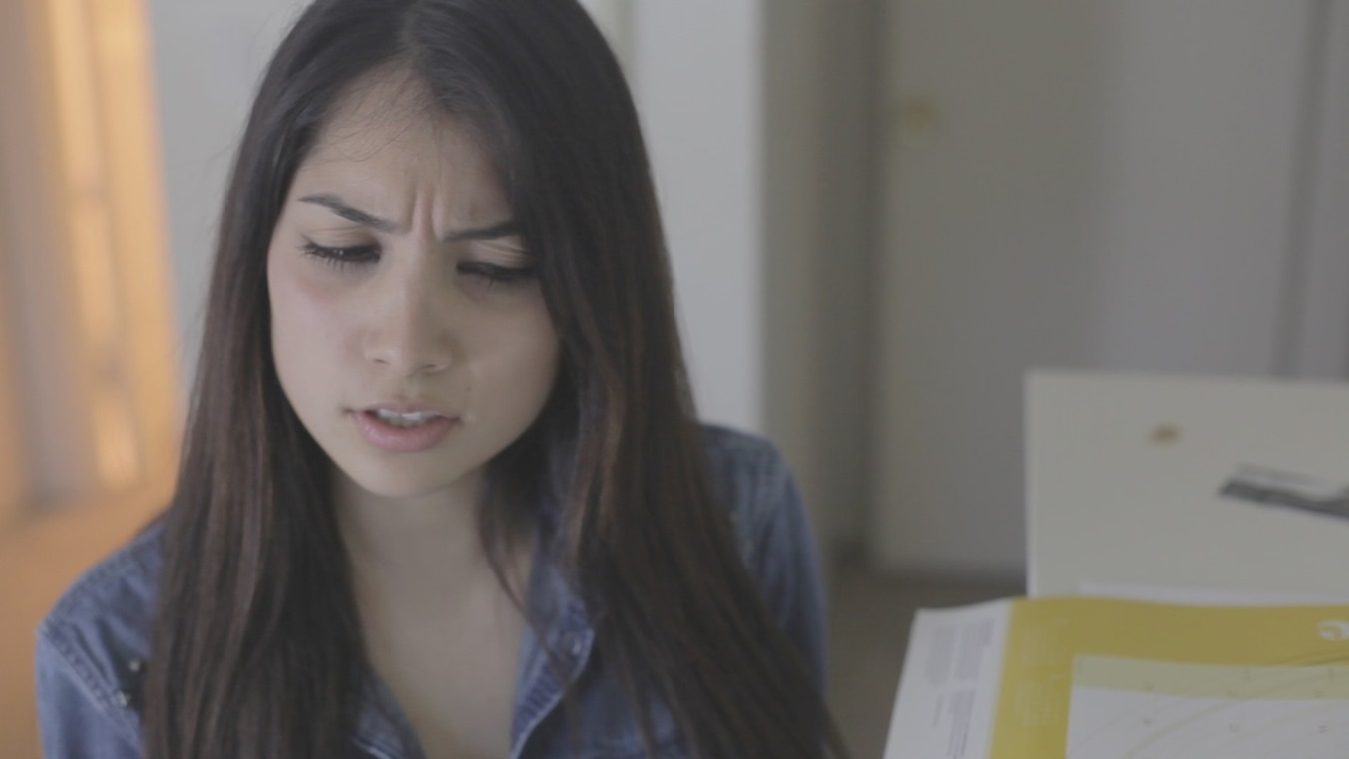
Aime Sosa as Kayla
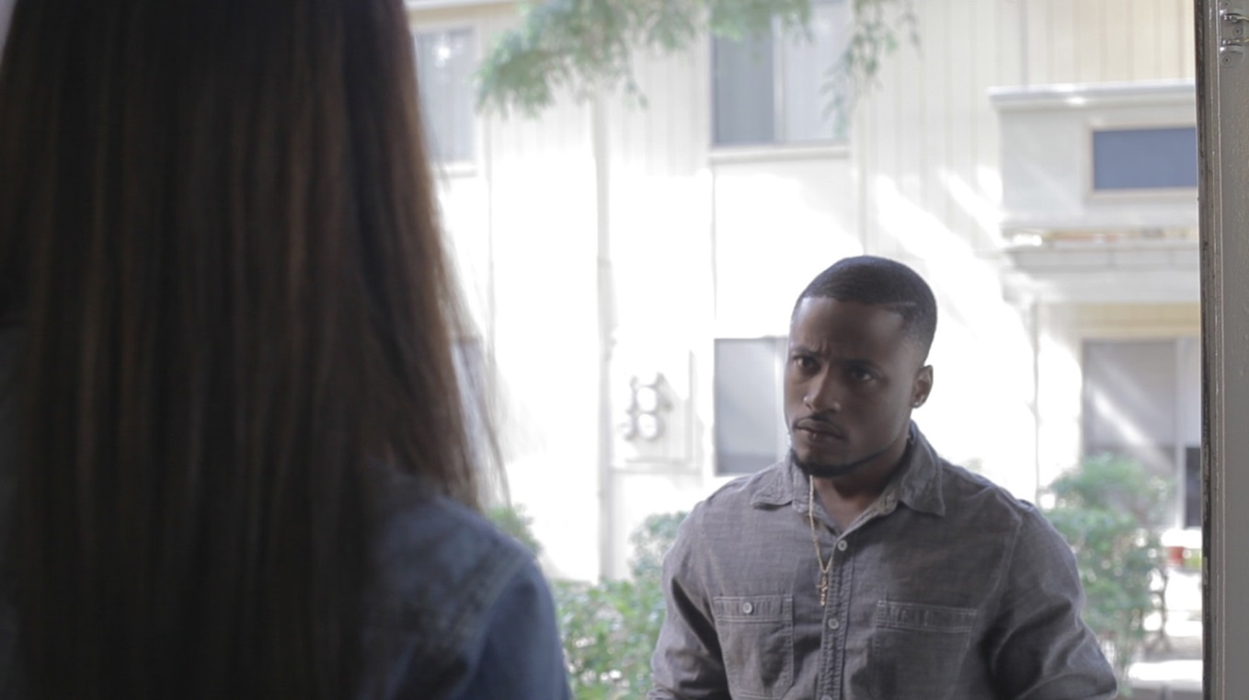
Chris Baker as Myles

Brandi King as Naomi

CREDITS

Antonio Michael Leaks- Director
Aime Sosa – Kayla
Brandi King – Naomi
Ike Torres- Ex Boyfriend
Chris Baker – Myles
Music by Jerry Sypkens

Costume Designer – Marquia Monteiro
Editor – Antonio Michael Leaks
Storyboarding – Erick Garrett
Casting Marquia Monteiro
Director of Photography Adrian Ehlman
Assistant Director Erick Garrett
Written and Directed by Antonio Michael Leaks

